Valley-Wide Elite Gymnastics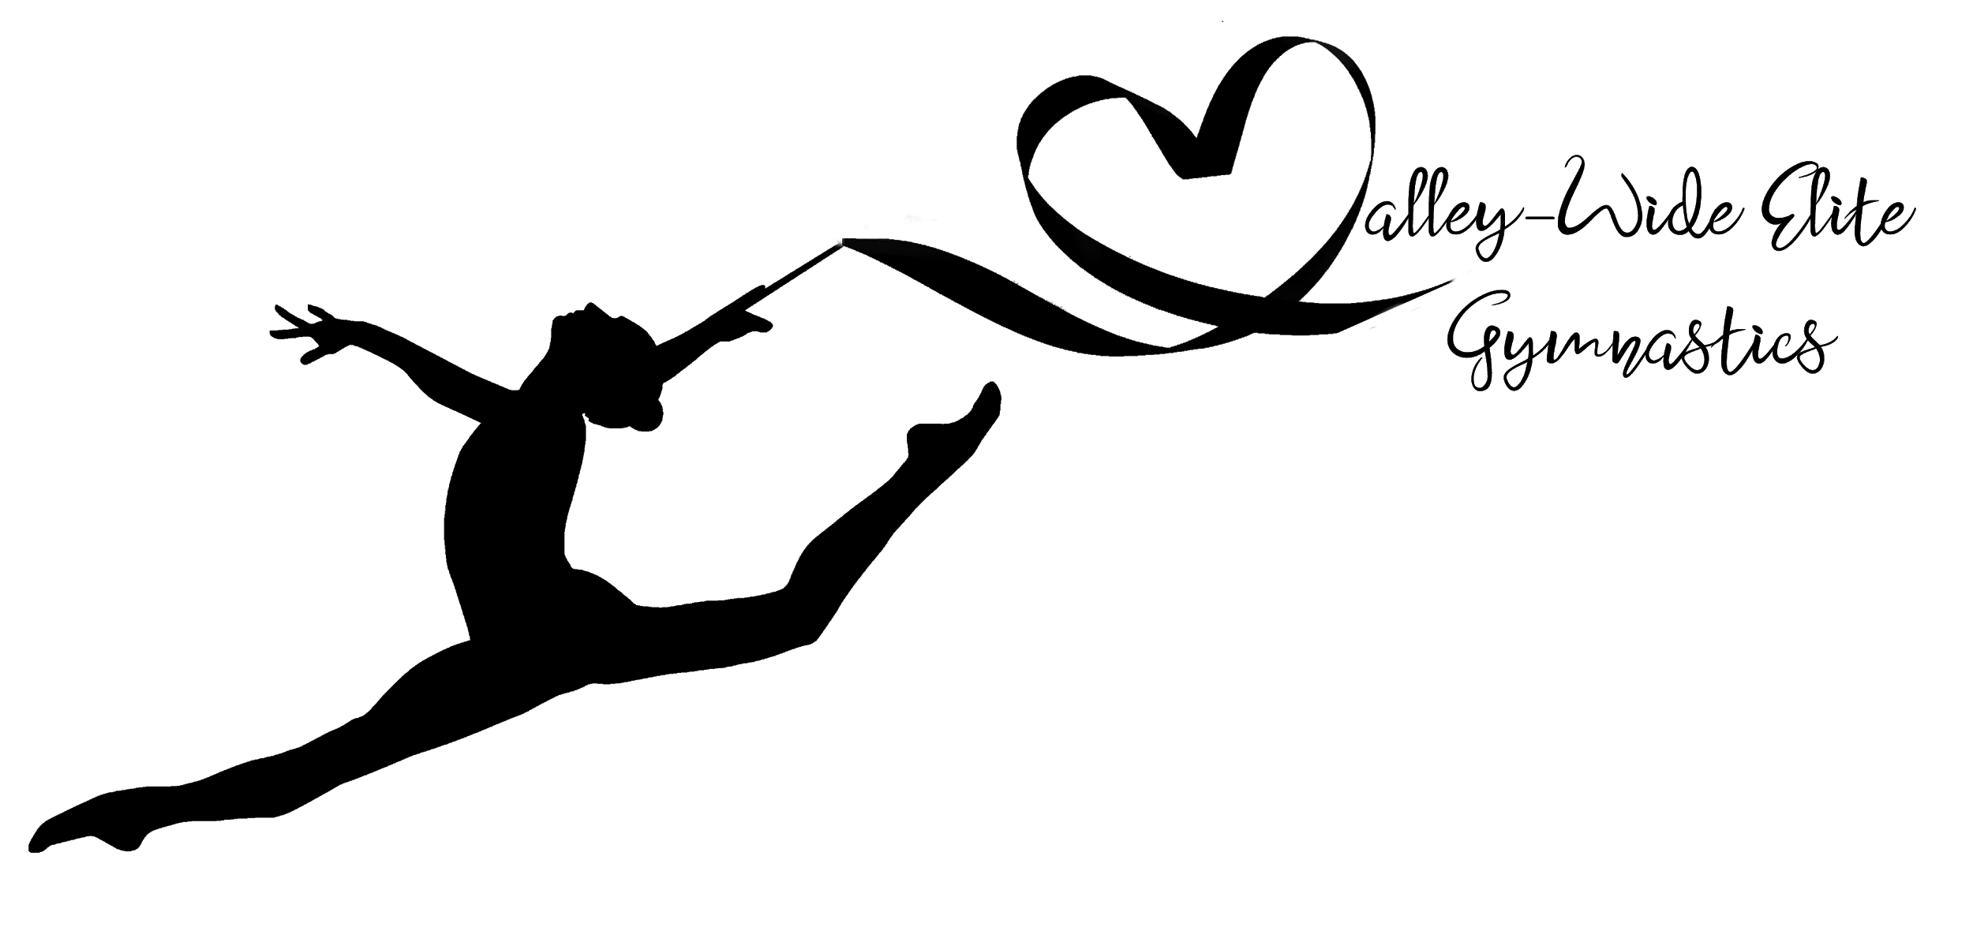

Waiver of Liability and Tuition Amendment Relating to Coronavirus/COVID-19 In response to COVID-19, Valley-Wide Elite Gymnastics has put into place preventative measures as recommended by federal, state, and local governments and state and local health agencies in order to reduce the spread of COVID-19 and the risk of infection. Additionally, Valley-Wide Elite Gymnastics relations to include tuition policies specific to any future gym closures relating to COVID-19. By signing this agreement, I acknowledge the contagious nature of COVID-19 and voluntarily assume the risk that my child(ren) and I may be exposed to or infected by COVID-19 by attending Valley-Wide Elite Gymnastics and I hereby release, covenant not to sue, and hold harmless Valley-Wide Elite Gymnastics, its owners, and its employees based on their actions, omissions, or negligence. I further acknowledge that while gymnastics, parkour, trampoline, and tumbling are individual sports, there will be occasions when incidental contact will occur. Although gymnastics programs at Valley-Wide Elite Gymnastics are operating in a physical distancing environment there will be times when the children breach the required distancing recommendation. In addition, our coaching staff will spot (physically assist) when the circumstances require it. Spotting our students and athletes is often necessary in order to teach skills safely, help children perform skills correctly, and to prevent injury. Furthermore, I understand the following amended tuition and make-up policy as it relates to closures caused by COVID-19:
● No refunds or credits on tuition will be provided for the remainder of any month during which gymnastics is forced to close. Upon reopening, make-up classes will be offered for any classes missed during the gym’s closure and can only be offered to enrolled and active students.

___________________________________
Signature of Parent/Guardian

______________________________
Date

